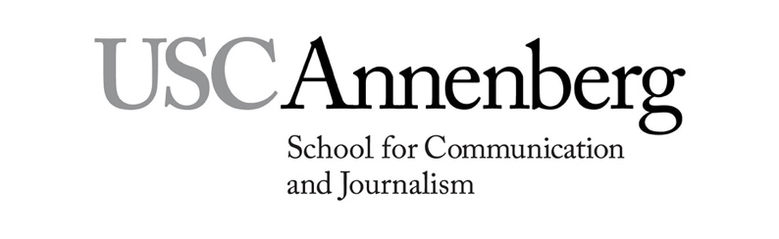
USC Annenberg Progressive Master’s Degree Application Guidelines
for December 2021 and May 2022 Graduating Seniors
Step 1: Identify the graduate degree program of interest to you
Communication Data Science* Journalism Specialized Journalism
Communication Management Public Diplomacy Specialized Journalism (The Arts)
Digital Social Media Public Relations and Advertising

*Communication Data Science is jointly taught by USC Annenberg and USC Viterbi. Although you may attend an Annenberg information session, the PDP application process is managed by USC Viterbi Admissions. For more information, visit USC Viterbi

Step 2: Attend an information session
Visit annenberg.usc.edu/progressiveinfo for dates and times of virtual sessions. Attend the breakout room for graduating seniors following the faculty presentations. Note: You must have a minimum cumulative USC GPA of 3.0 to apply for admission.

Step 3: Consult with USC Financial Aid about financing your graduate education
Visit Financial Aid Enrollment in a Progressive Degree Program for more details. Contact fao@usc.edu if you have specific questions.

Step 4: Meet with your undergraduate academic adviser
All majors: Download Progressive Degree Application materials from USC Undergraduate Education website at https://undergrad.usc.edu/programs/progressive/. Your academic adviser will add your current and future undergraduate courses to the Proposed Course Plan and complete/sign the Annenberg Progressive Degree Route Slip.
Annenberg majors: Academic advisers will be available Nov. 15–Dec. 15, 2021 and Jan. 10–Feb. 14, 2022. Appointments after Feb. 14, 2022 may be accepted as needed on a case-by-case basis. Mar. 20, 2022 is the deadline for all appointments. Undergraduate department chair and dean’s signature will be obtained by Annenberg Admissions.
Non-Annenberg majors and double majors outside of Annenberg: You must obtain the signatures from your non-Annenberg dean (on the Application for Admission to Progressive Master’s Program and undergraduate department chair and undergraduate department dean on the Proposed Course Plan prior to Step 5.
Step 5: Meet with an Annenberg graduate academic adviser
Email your signed Proposed Course Plan and Annenberg Progressive Degree Route Slip to the appropriate graduate adviser and request a meeting to discuss the graduate-level courses. The graduate academic adviser will add the graduate courses to your Proposed Course Plan and sign the Annenberg Progressive Degree Route Slip.
Communication Management – Susan Zhang – zhangmen@usc.edu
Digital Social Media and Public Diplomacy – Nicole Valdez – nicoleva@usc.edu
All Journalism degree programs and Public Relations and Advertising – Mike Ploszek – mploszek@usc.edu
All majors: Appointments with graduate academic advisers are available Nov. 15– Dec. 15, 2021 and Jan. 10–Feb. 14, 2022. Appointments
after Feb. 14, 2022 may be accepted as needed on a case-by-case basis; Mar. 20, 2022 is the deadline for all appointments. Signatures from Annenberg master’s program chair and master’s program dean will be obtained by Annenberg Admissions.

Step 6: Submit your PDP application materials by the application deadline
Email your application materials in PDF format to allysonh@usc.edu by April 1, 2022 for all journalism graduate degree programs and May 1, 2022 for all other graduate degree programs. Your application must include:
- Application for Admission to Progressive Master’s Degree Program.
- USC Proposed Course Plan and Annenberg Progressive Degree Route Slip.
- Copy of updated STARS report
- Résumé – Include your permanent home address and academic awards, USC honors, scholarships, association memberships, research experience, computer literacy and foreign language skills. Your résumé may exceed one page.
- Letter of recommendation – One letter is required if your cumulative USC GPA is below 3.49. After indicating your access rights and providing your e-signature, forward the Progressive Master’s Degree Recommendation Form to a USC faculty member that taught you in a USC class. The letter with the form may be emailed directly to allysonh@usc.edu from the faculty member.

Step 7: Admission process and notification
Complete applications are reviewed by Annenberg faculty admission committees. Once a decision is made, USC Annenberg Graduate Advisement will contact you via email. For answers to application questions, contact Allyson Hill, Associate Dean of Annenberg Admissions and PDP department coordinator, at allysonh@usc.edu

