RON ANTONETTE

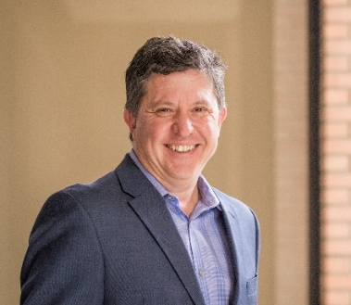

Ron Antonette works directly with C-level executives, business owners and municipal government staff on branding and communications issues, and provides public relations counsel to international companies, small businesses, and start-ups. Since founding the Long Beach-based “micro-agency” R. Antonette Communications in 2009, Ron has balanced national brand work with regional communications projects. His recent work with government organizations include projects with the cities of Long Beach (Bike Long Beach, Port of Long Beach), Los Angeles (LADOT/Vision Zero), Claremont (for its Tourism Business Improvement District), and Palos Verdes Estates (website and social media). Corporate clients include work for CPA Australia, Fellowes Brands, Hampton Products International and the Southland Motor Car Dealers Association. Ron also works with graduate students and PR industry leaders as the chief program officer at the University of Southern California’s Center for Public Relations.

Ron’s communications experience includes working with food & beverage, retail and franchise brands, launching consumer tech products, managing special events, and working with government organizations. He has worked on an eclectic mix of creative, consumer brand PR campaigns and projects – from baby dolls and bottled water to showerheads and Swatch watches.

During more than 14 years at Golin, Ron was the senior executive on the agency’s Mattel and Nestlé accounts, and directed many of the firm’s programs for Disney, including the launch of the Go Network, and the Poohfest and Mickey’s Hometown Parade campaigns. He helped raise the profiles of clients Cold Stone Creamery, Interbath, Musicmatch, Peet’s Coffee & Tea, and Playmates (Teenage Mutant Ninja Turtles), and led projects for Amazon.com and Toyota/Scion. His team helped open The Venetian in Las Vegas, Disney’s California Adventure, Disneyland’s reimagined Tomorrowland, Cold Stone Creamery’s Times Square location, and many retail outlets.

At FleishmanHillard, Ron co-led its national consumer marketing practice and contributed to national work for Safeway, Magellan GPS and Enterprise Rent-A-Car. Ron has also held in-house roles at Mattel as director of brand public relations for its Boys division, including work for Hot Wheels and electronics, and ConAgra Foods supporting its shelf-stable food brands (Chef Boyardee, Hunt’s) and handling crisis communications. He has accompanied Star Trek celebrities atop the Empire State Building, WWE superstars at Toy Fair, celebrity chefs at retail events, Turtle Claus at the Rockefeller Center Tree Lighting, and Mickey Mouse on Main Street in Platteville, Wisconsin, to name a few unusual photo opportunities.

Active in community and youth sports locally, Ron served eight years on Long Beach’s Parks and Recreation Commission and is now board president of the Partners of Parks non-profit. He is a member of the Long Beach Century Club, Team 100 Food for Kids project, and a game official and basketball announcer at Millikan High School. He also is a member of the Motor Press Guild and the Public Relations Society of America (PRSA) and its national Counselors Academy.

A trustee scholar at the University of Southern California, Ron earned a bachelor's degree in journalism/public relations, sports information emphasis, and was program director of student radio station KSCR. He and his wife, Cynthia, have two school-aged children, and spend many weekends coaching and refereeing youth soccer.

